The Stormlight Archive [04] Rhythm Of War [01]….[M4B] - Brandon Sanderson
Category: Adventure, Fantasy, Full Cast, Teen & Young Adult
Language: EnglishKeywords:

Graphic Audio

GraphicAudio

M4B

Rhythm Of War

The Stormlight Archive
Shared by:Pamar
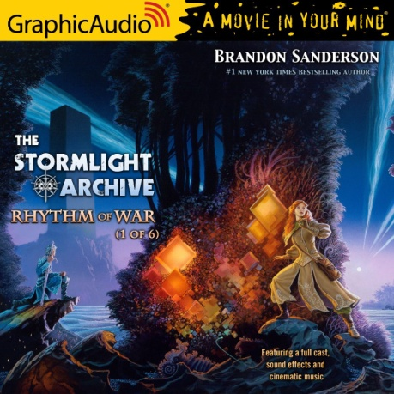
Written by Brandon Sanderson
Read by GraphicAudio, Graphic Audio
Format: M4B
Bitrate: 256 Kbps
Dramatization
==========================================================================
[] MY COMPUTER IS NOT ALWAYS ON ~ PLEASE ALLOW TIME FOR THE DOWNLOAD. []
================================================
By : Brandon Sanderson
Release Date : December 21, 2020
Approximate Running Time : 7 Hours
Content Rating : Ages 13+
After forming a coalition of human resistance against the enemy invasion, Dalinar Kholin and his Knights Radiant have spent a year fighting a protracted, brutal war. Neither side has gained an advantage, and the threat of a betrayal by Dalinar’s crafty ally Taravangian looms over every strategic move.
Now, as new technological discoveries by Navani Kholin’s scholars begin to change the face of the war, the enemy prepares a bold and dangerous operation. The arms race that follows will challenge the very core of the Radiant ideals, and potentially reveal the secrets of the ancient tower that was once the heart of their strength.
At the same time that Kaladin Stormblessed must come to grips with his changing role within the Knights Radiant, his Windrunners face their own problem: As more and more deadly enemy Fused awaken to wage war, no more honorspren are willing to bond with humans to increase the number of Radiants. Adolin and Shallan must lead the coalition’s envoy to the honorspren stronghold of Lasting Integrity and either convince the spren to join the cause against the evil god Odium, or personally face the storm of failure.
© 2020 by Brandon Sanderson. Recorded with the permission of the Author and Dragonsteel Entertainment, LLC Production. Published by arrangement with Macmillan publishing group LLC d/b/a Tor Books. All Rights Reserved. ℗ 2020 Graphic Audio, LLC. All rights reserved.
*****************************************
** MANY THANKS TO THE ORIGINAL UPLOADER **
*****************************************
****************************
** PLEASE CONTINUE TO SEED **
**** AFTER DOWNLOADING ****
****************************
*********************************************
****** PLEASE CONTACT ME ON THE FORUM IF ******
*********** THERE ARE ANY PROBLEMS ***********
*********************************************

